- Description of activities/events/launches/bootcamps

Generation unlimited activities started with the launch of the Generation Unlimited Youth challenge in 2019. Since September 2019, UNICEF in collaboration with UNDP, has been working on this great initiative for young people.

So far, the Youth Challenge was officially launched by the Ministry of Youth and was followed by outreaches which are done through our partners.

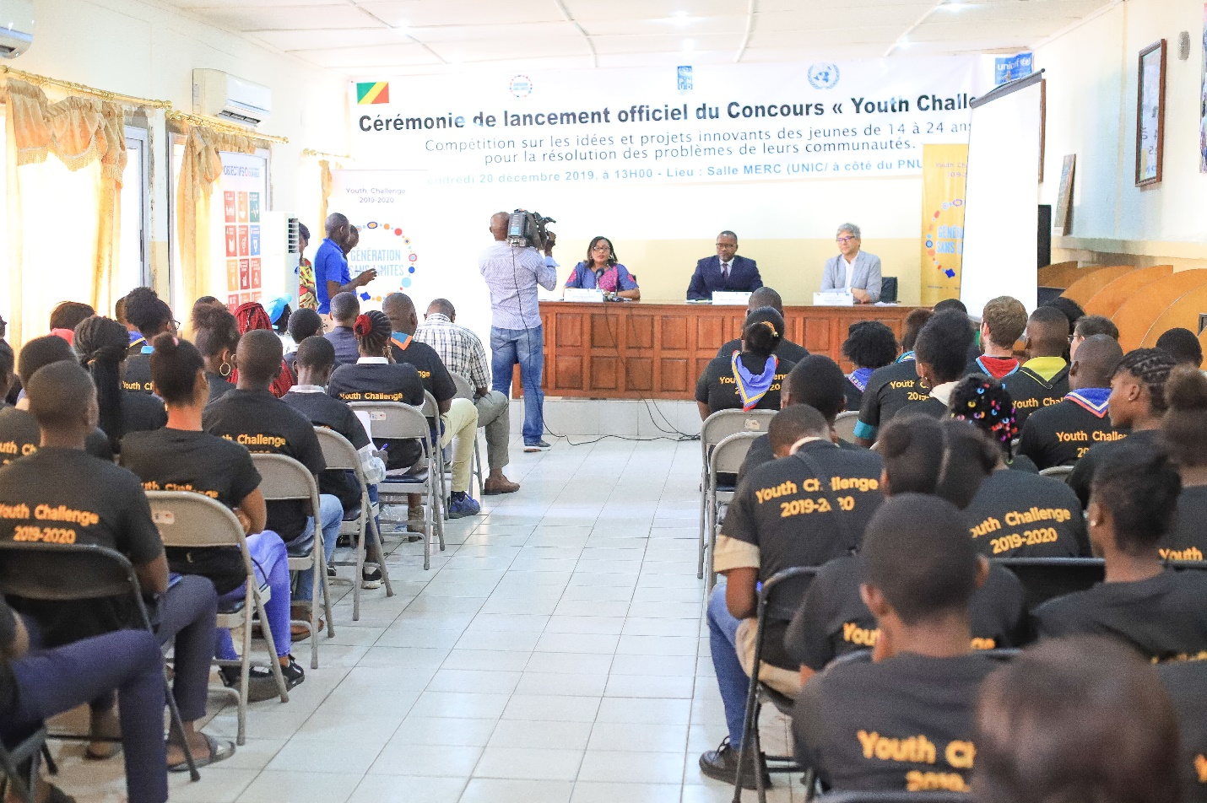

- Partners involved

Though the Generation Unlimited activities have just started, UNICEF had already worked with different partners to ensure young people’s participation and to promote their development. So, UNICEF worked with the same partners for the Generation Unlimited Youth Challenge. Some of these partners are the FAWE Congo for Girls education they worked with UNICEF to create and manage school clubs, the SCOUTS, they have been working with UNICEF for many activities such immunization campaign, breastfeeding campaigns, etc. Apart from the above, other partners are involved such the Radio Citoyenne des Jeunes and other Youth associations.

As we are co-leading the GenU Youth Challenge with UNPD, we are working with partners of UNDP too, including the civil society, NGOs, Youth-led associations, and government institutions.

- Results achieved

Since the launch, more than 200 young people were sensitized through outreaches. On our social media platforms, we managed to reach 10 667 followers with 1022 interactions (likes, comments and shares). Radio Citoyenne des jeunes was able to broadcast a press release for a week, reaching 300 young people.

- Challenges

One major challenge we encountered was the insufficiency of the funds. The initial funding allocated for the initiative was not enough to cover all the expenses. The two agencies involved had to find ways to cover the extra expenses that came up and couldn’t be avoided. The late availability and insufficiency of the funds delayed the launch of activities. The global timeline is also tight but for that we managed to adapt.

- Plans going forward

In the next few weeks, we will select 10 finalist who will participate in the bootcamps before the final selection of five best groups out of which two will represent the country globally in June. These five groups will receive a mentorship and coaching throughout the implementation of their projects in the coming months.

- Any documentation you would like to attach

We shall attach a few documents: Letter of invitation for the launch, Youth challenge flyer, the application form and some pictures

- Any other reactions

